is your child’s date of birth between
1st March 2016 & 28th Feb 2017?
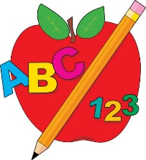
If so, they are due to start Primary 1 in August 2021.

Once you receive your letter in the post, please go online and enrol them for school by 13th Nov. 2020. You can access information without a letter.
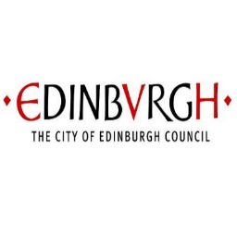
The P1 Registration webpage is now live.

www.edinburgh.gov.uk/p1registration

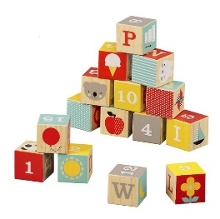
Please sign up for your catchment school.

- You may choose to make a non-catchment request at the same time. However, you MUST also enrol at your catchment school.

If you require help or further advice with this process, please talk in the first instance to nursery staff team. NB. They cannot confirm places or availability.

Please share this info. with friends, families and neighbours to ensure that all families wishing a P1 place in an Edinburgh school, sign up in good time.

